ASSIGNMENT 6.5

1.Write a pig script to find the top 20 destination people travel the most: Based on the given data .

STEP 1:LOAD THE RELATION REL AND ADD DATA INTO IT

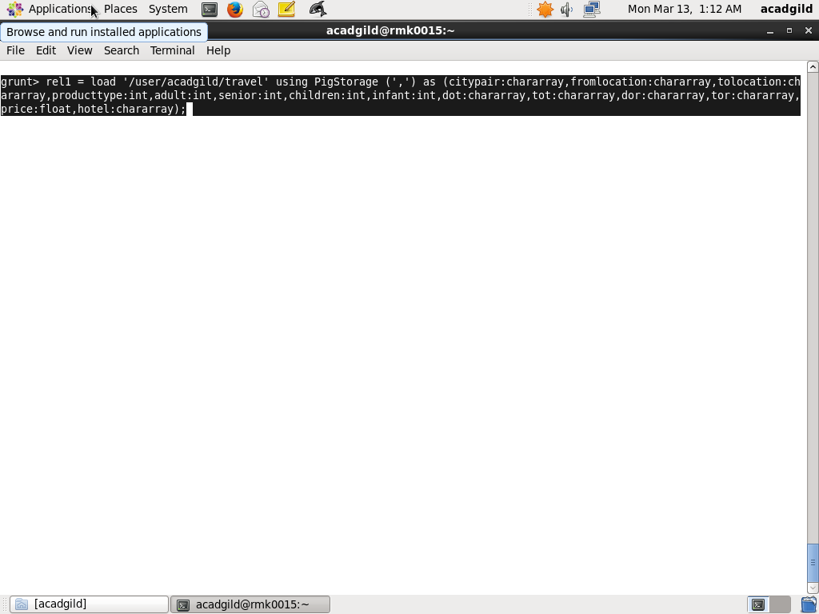

STEP2 : AFTER DUMPING THE REQUIRED DATA IS AS FOLLOWS

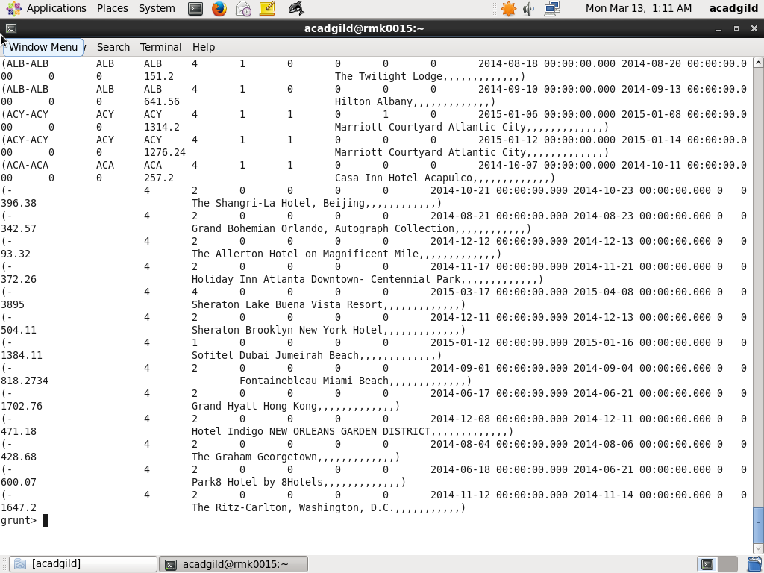

STEP 3: Grouping relation by tolocation,so that we have the same tolocations grouped together.

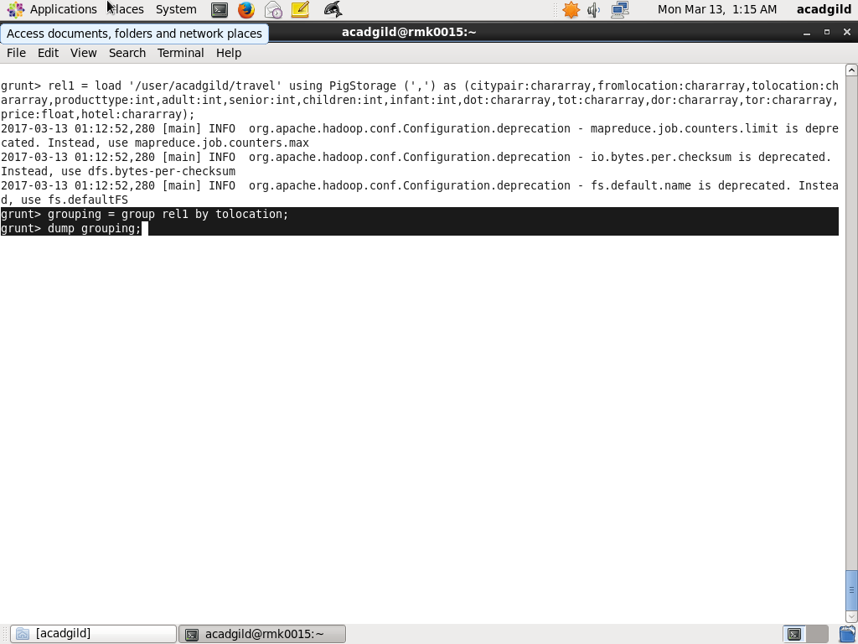

STEP4:use for each to count the no.of visits and then order them in decending order

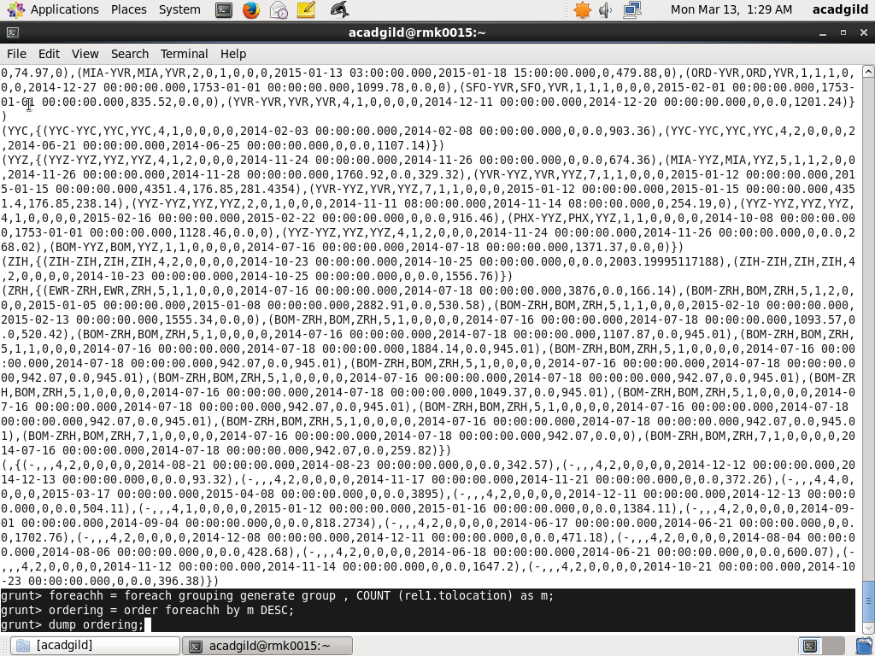

STEP 5:result of ordering in descending order of visits made

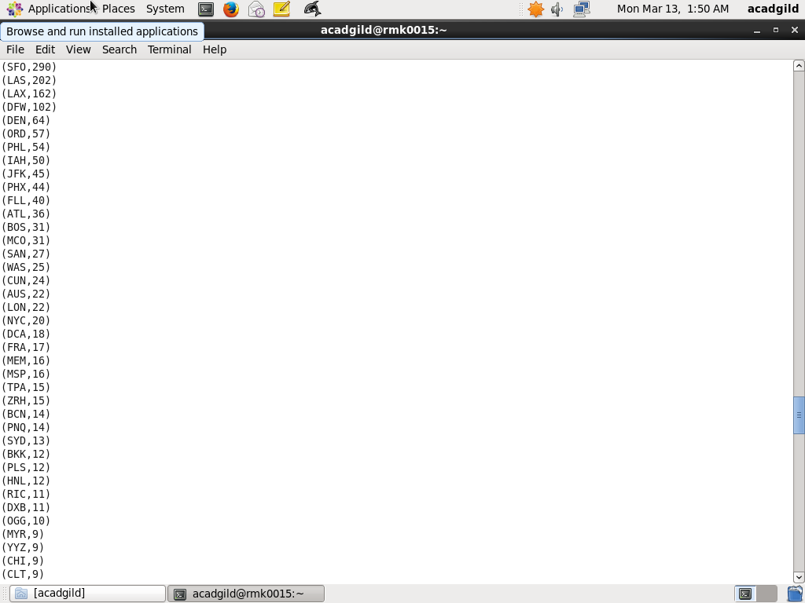

STEP 6:limit the above list to range of 20

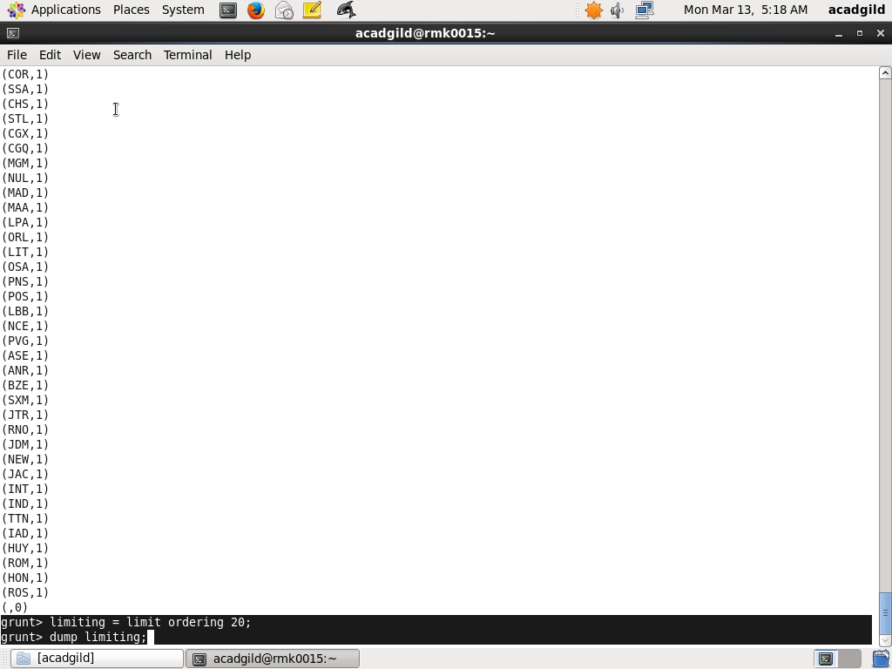

STEP 7: Result of limiting to 20 details described

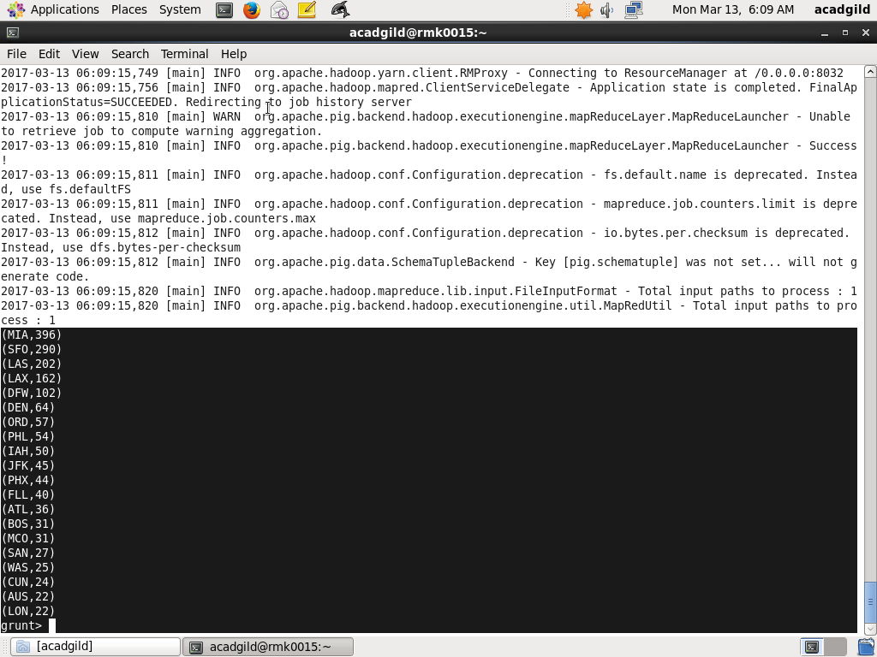

STEP 8:USE FOR EACH TO CREATE A GROUP OF TOP 20 TRAVELLED DESTINATIONS

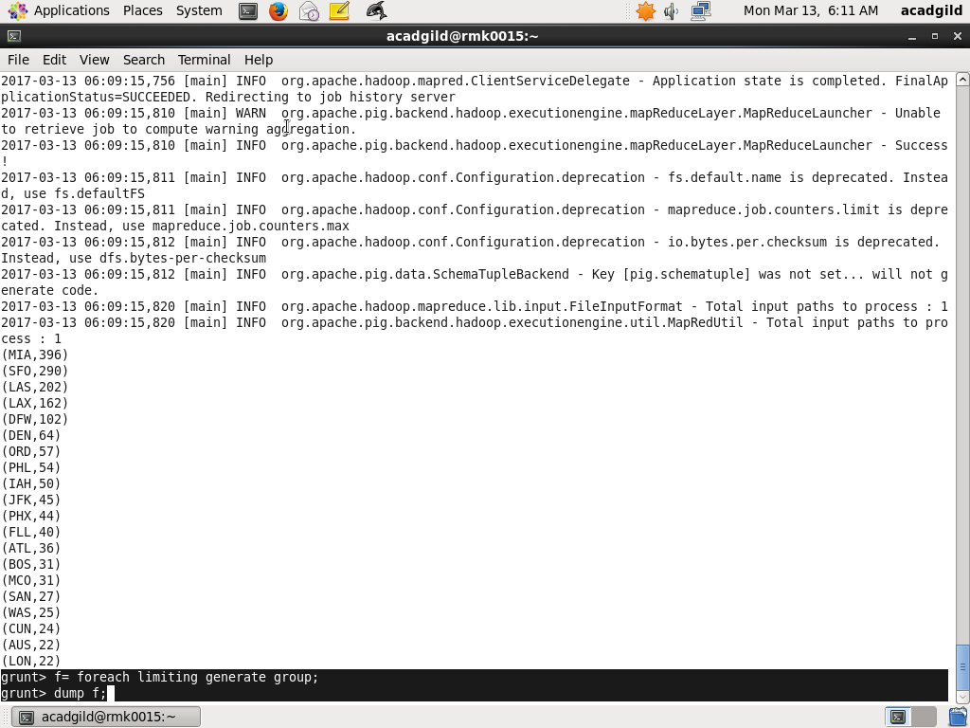

**OUTPUT**

STEP 8: OUTPUT SHOWING TOP 20 DESTINATIONS PEOPLE TTRAVEL THE MOST

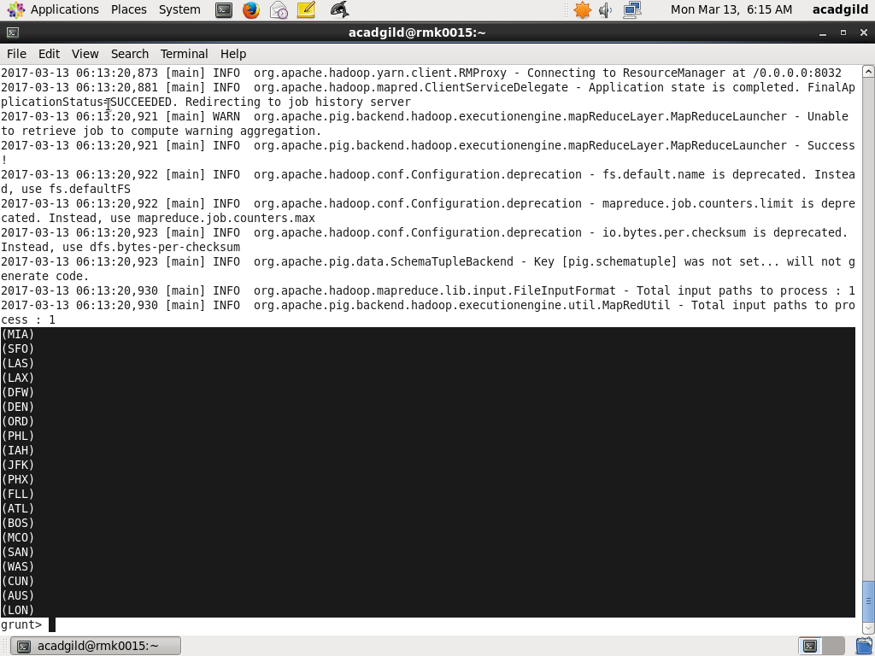

2. Write a pig script to find the top 20 locations from where people travel the most

STEP 1:AFTER LOADING INTO RELATION NOW GROUP BASED ON “FROMLOCATION” ,THEN USE FOREACH TO DISPLAY FIELDS ,LATER ORDER THEM BASED ON COUNT IN DESCENDING ORDER.

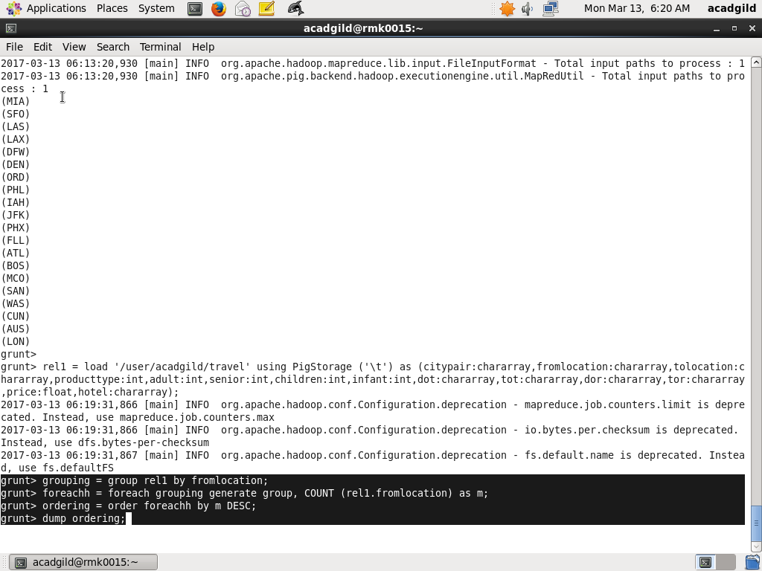

STEP 2: RESULT AFTER DUMPING THE ORDERED DATA

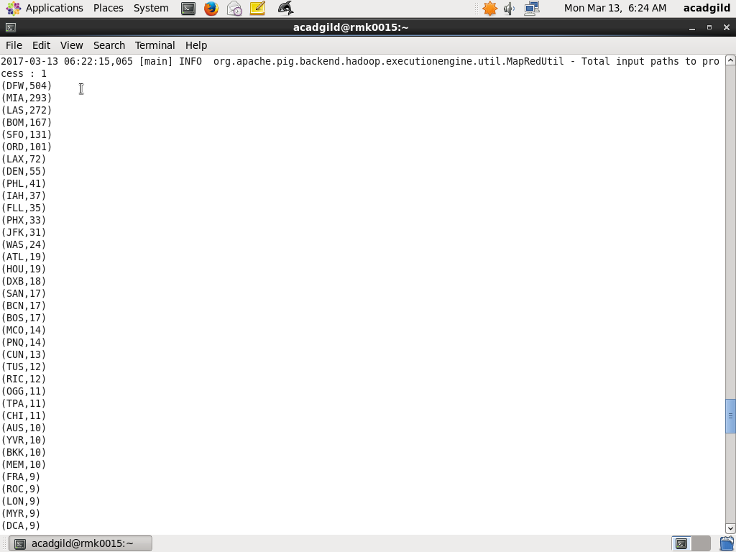

STEP 3: USE THE “LIMIT” TO GET TOP 20 RANGED FIELDS

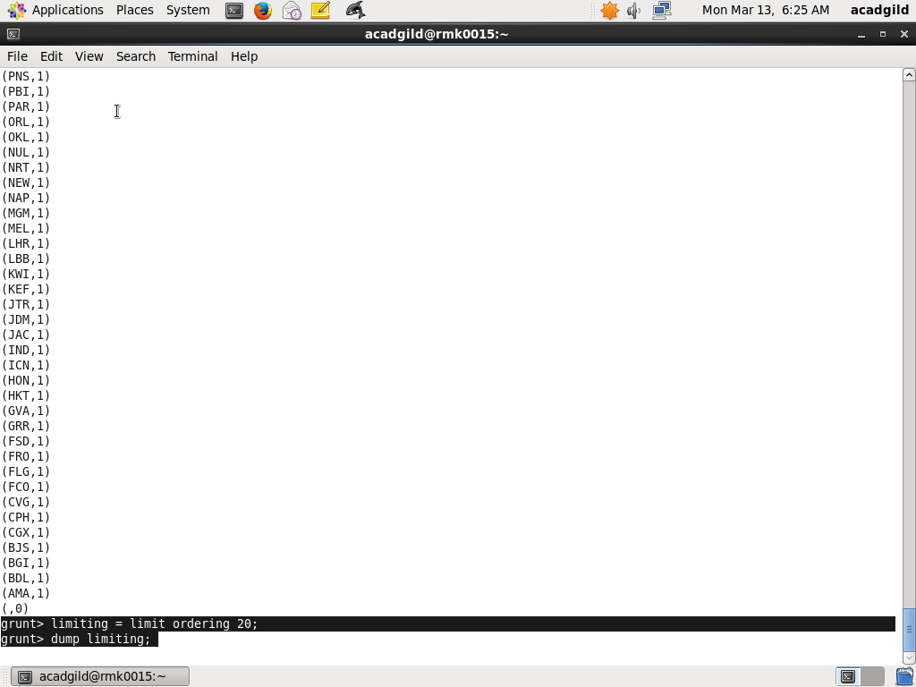

STEP 4: AFTER LIMITING THIS DISPLAYS TOP 20 LOCATIONS FROM WHERE PEOPLE TRAVEL MOST

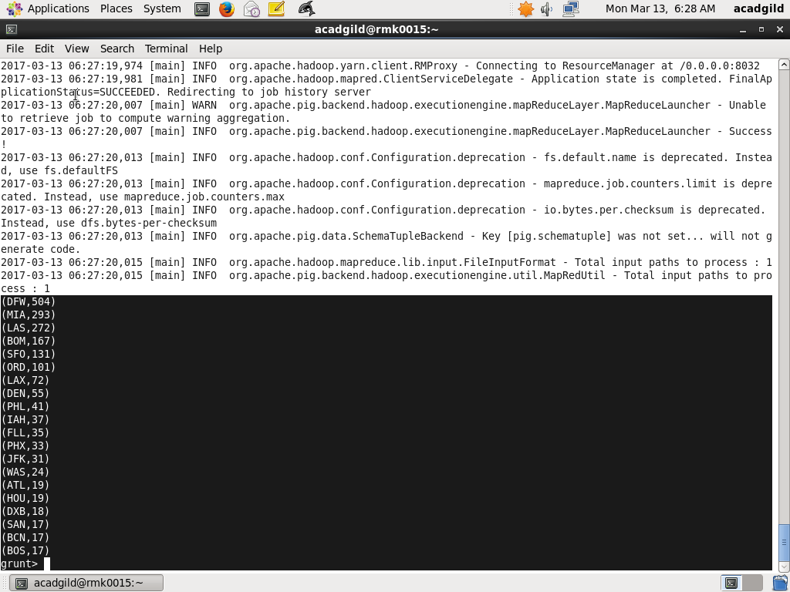

STEP 5: USE FOR EACH TO DISPLAY LOCATION TAT PEOPLE TRAVEL THE MOST

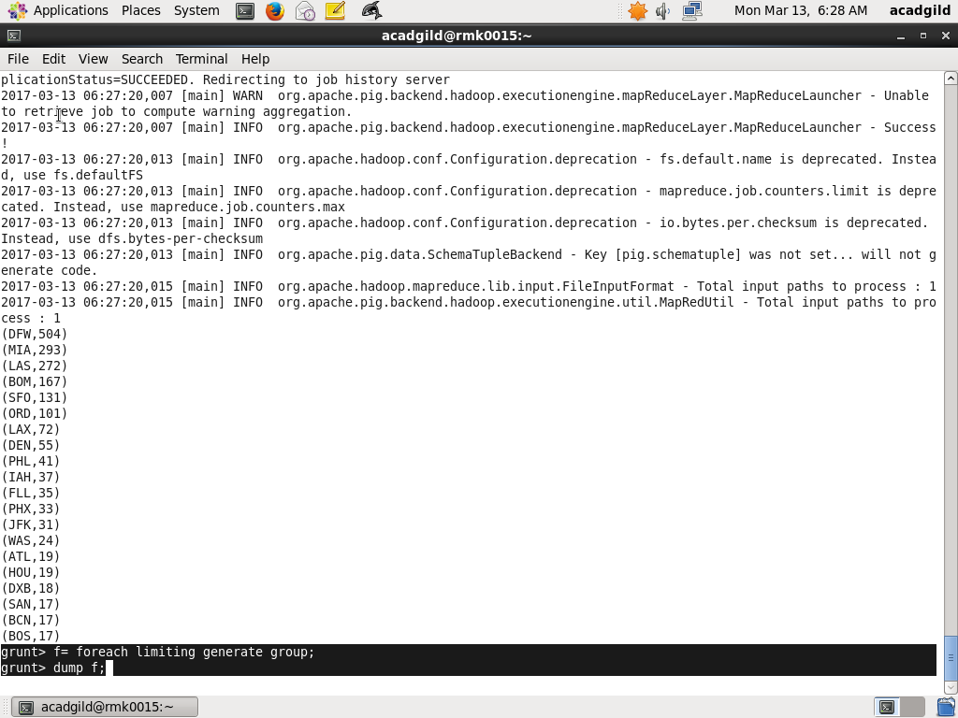

**OUTPUT**:

STEP 6: OUTPUT SHOWING THE TOP 20 LOCATIONS FROM WHERE PEOPLE TRAVEL MOST

